**Project Report**

***Zomato Data Analysis***

**Name** :- *Prerana Pundlik Rajput*

**Project Name** :- *Zomato Data Analysis*

**Date** :- *4 December 2024*

**Technology** :- *Language “ Python”*

**Library** :- *NumPy, Pandas, Matplotlib, Seaborn*

## Project Description

This project aims to analyze data from Zomato, a popular restaurant discovery and food delivery platform. The dataset includes details about various restaurants and their offerings. By analyzing this data, we can gain insights into restaurant ratings, order types, customer preferences, and pricing trends.

## Data Dictionary:

* **Name:**

The name of the restaurant.

* **Online order:**

Indicating whether the restaurant accepts online orders.

* **Bookable**:

indicating if the restaurant accepts table reservations.

* **Rate:**

The average rating of the restaurant on the platform.

* **Votes:**

The number of customers votes or reviews the restaurant has received.

* **Approx Cost for Two People:**

The approximate cost for a meal for two people at the restaurant.

* **Type:**

The type of cuisine or restaurant, such as Fine The type of cuisine or restaurant, such as Fine Cafes, Buffet, Dining.

## Data Cleaning and Preprocessing:

Before analyzing the data, the following steps are performed:

* **Data Conversion:**

The "Rate" column is converted to a numerical format for easier analysis. The "Approx Cost for Two People" is cleaned by removing non-numeric characters.

* **Category Encoding:**

For categorical columns like "Online Order," "Bookable," and "Type," encoding is applied to convert them into numeric values.

* **Exploratory Data Analysis (EDA):**

The goal of EDA is to understand the underlying patterns and relationships in the data. The following analyses are performed.

* **Rating Distribution:**

A distribution plot of the ratings is plotted to understand how restaurants are rated by customers. We identify whether most restaurants have high ratings or low ratings and examine the overall trend.

* **Online Orders vs Bookable:**

A comparison of online order availability and table booking status is performed. This helps in understanding if restaurants offering online orders also provide table reservations.

* **Cost Analysis:**

The average cost for two people is analyzed across different types of restaurants. This allows us to categorize restaurants by price range.

* **Restaurant type insights:**

The dataset is divided based on restaurant types (Cafes, Buffet, Dining etc.). The relationship between restaurant types and their average ratings, votes, and cost is analyzed.

# Data Visualization:

Graphs and charts are created to visualize key findings from the analysis:

* **Bar graphs**: To display the distribution of restaurant do the majority of customers order from, average spending on each order.
* **Box Plot**: Mode which has received maximum rating displayed by box plot.
* **Heat Map**: To display which type of restaurant received more offline orders.
* **Line Plot:** To display how many votes has each type of restaurant received from customers.

**Key findings:**

* **Online Orders and Offline orders:**

Offline orders received lower ratings in comparison to online orders, which obtained excellent ratings.

* **Type of restaurant:**

The majority of the restaurants fall into the dining category.

* **Votes:**

Dining restaurants are preferred by a larger number of individuals.

* **Rating:**

majority of restaurants received ratings from 3.5 to 4.0

* **Mode:**

Offline orders received lower ratings in comparison to online orders, which obtained excellent ratings.

**Future Work:**

**Further analysis can include:**

* Sentiment analysis of customer reviews to gauge customer satisfaction more accurately.
* Time series analysis of restaurant popularity over different months or seasons.

**Recommendations:**

* Restaurants should focus on improving their offline presence as offline orders are becoming increasingly popular.
* Restaurants with higher ratings and more votes should invest in further improving customer experiences to maintain their competitive edge.
* Pricing strategies can be tailored based on restaurant type and customer preferences to attract more customers.

# Project Snapshot

1. **This graph shows what type of restaurant do the majority of customers order from.**

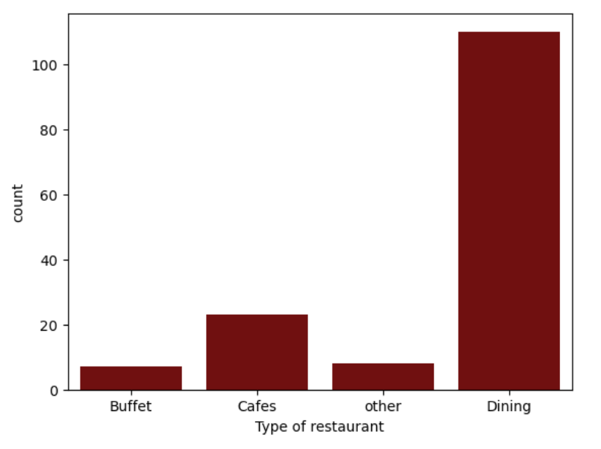

1. **This graph shows how many votes has each type of restaurant received from customers.**

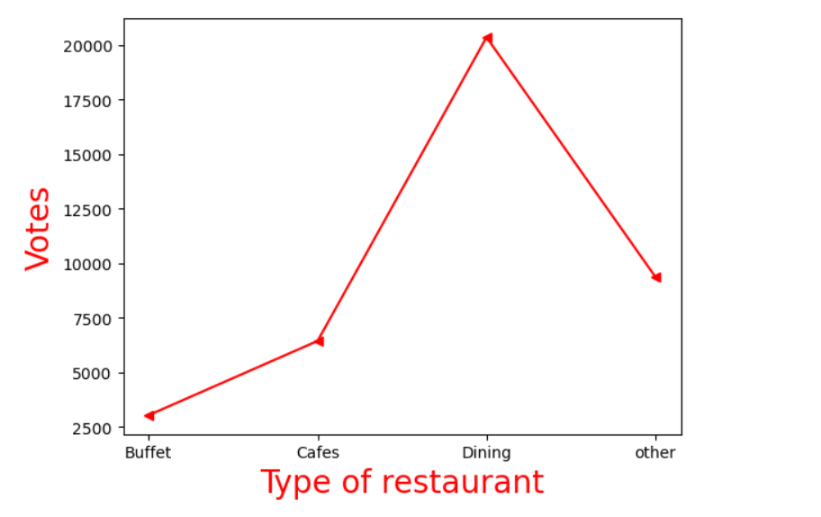

1. **This graph shows how ratings that the majority of restaurants have received.**

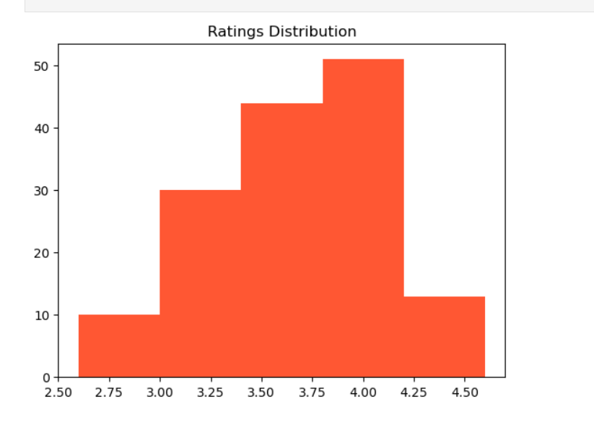

**4.This graph shows average spending on each order.**

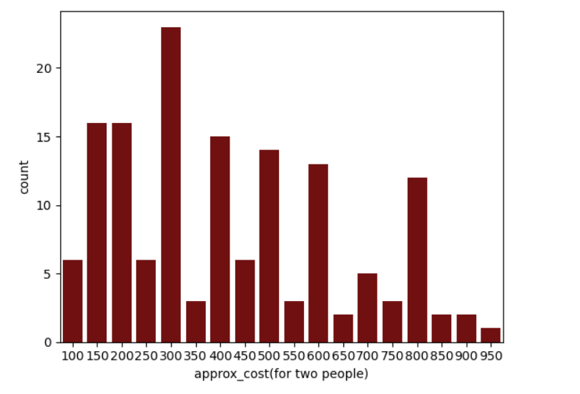

**5.This graph shows which mode has received maximum rating.**

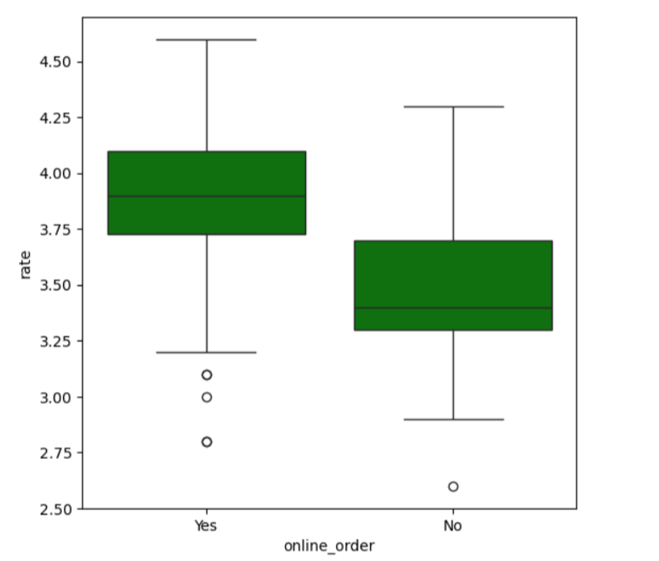

**6.From this graph shows which type restaurant received more offline orders.**

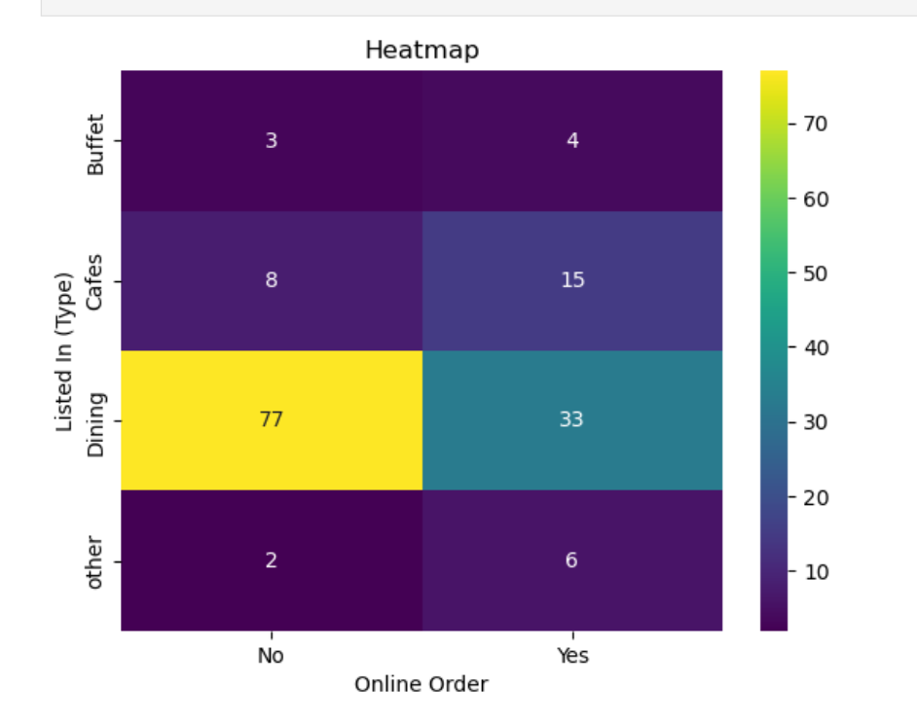

**Conclusion :**

This analysis provides valuable insights into restaurant trends, customer preferences, and the relationship between restaurant ratings and features like cost and type. The findings can help restaurateurs understand customer behavior, improve their offerings, and make data-driven decisions.